Curiculum Vitae

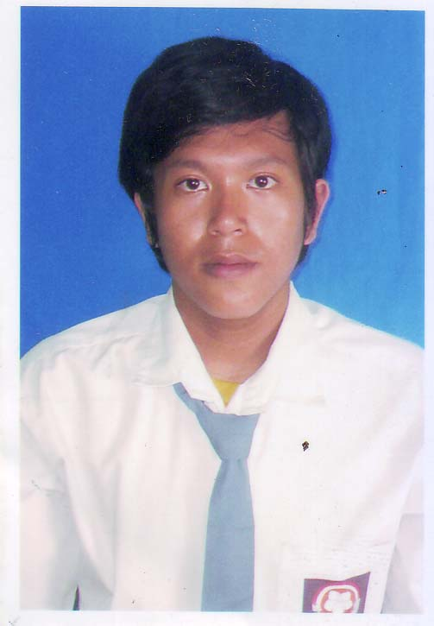

Miyzan Anjar Pamuksoro

Adress. : Kp. Jembatan Jl. Cipinang Besar Selatan no. 03 Rt.011 Rw. 006
Kel. Cipinang Besar Selatan Kec. Jatinegara Jakarta Timur 13410
Phone. : 0812 5819 3338 / 0812 9464 4429
Place of Birth : Jakarta
Date of Birth. : April 29th, 1990
Gender. : Male
Email. : anjarpamuksoro29@gmail.com
Height / waight : 170cm / 70kg

Education

2005 – 2008 : SMU Bhakti Samoedra , Jakarta
2002 – 2005 : SMPN 27 , Jakarta
1996 – 2002 : SDN 10 , Jakarta
1994 – 1996 :TK Setya , Jakarta

Experience
Maret 2017 - Juni 2019 : Toko Gadai Top Indonesia ( Kepala Toko)
September 2016 - Desember 2016 : Pt inbisco niagatama semesta / Mayora ( MD institusi Horeka )
Maret 2016 - September 2016. : Orang Tua .group / OT (surveyor banch tradisional)
April 2015 - November 2015. : Pt inbisco niagatama semesta / Mayora ( MD institusi Horeka )
Juli 2014 - January 2015. : CT corp / mega finance ( collector )
Juni 2013 - Desember 2013 : Pt. Indomarco Prismatama ( Surveyor )
February 2012 - Agustus 2012 : Pt. Yudistira komponen ( PPIC )
January 2011 - September 2011 : Pt. Dinamika Mitra Pratama ( Internal Audit )
September 2010 - December 2010 : Restaurant Little Penang ( kitchen crew )
January 2009 - Maret 2009 : Restaurant Over Rice ( waiters )

